

**CST 2120**

**Web Applications and Databases**

**Coursework 3-Single Page Web Application**

STUDENT ID: M00738037

NAME: Uzma Tajuddin Shaikh

TUTOR: Ms. Engie Bashir

CAMPUS: Dubai





**Abstract**

**This document reports the description and provides screenshots and testing for the CST2120 Coursework 3. This coursework required the creation of a Single Page Web Application using Node.js and Ajax. The Website is a recipe-sharing website which requires the user to register for sharing a website. The data was stored in Heidi.sql. Once the website was created, the HTML, CSS, functions and JavaScript were tested using Selenium IDE, Mocha Chai tests and a validator.**

**Table of Contents**

**Introduction** 4

**Website Description** 4

**Screenshots** 5

**Testing** 8

**Conclusion** 13

**Sugar Rush**

# **Introduction**

**This website is a single-page web application called ‘*Sugar Rush’* which takes inputs from the user and stores them in the SQL database. The website mainly focuses on sharing recipes for desserts like donuts, shakes, macaroons and cakes. For adding their recipe, the user needs to have an account in the website. If the user does not have an account he can register and create one.**

# **Website Description**

* **Index Page**

**The index.html page is where all the functionalities of the website take place. Firstly it contains the navigation bar which consists of the logo of the website with the name ‘Sugar Rush’. It also contains the Register, Login and Recipe buttons, which takes the user to that section in the page. The page also displays a few categories of desserts like- Donuts, Shakes, Macaroons and Cakes. Below that the page has a section containing the registration and Login function. Below this section, all the recipes from the SQL database are displayed. It also contains an Add Recipe section which is visible once the user is logged in. Lastly, it contains a footer with links to privacy policy, help centre, terms & conditions and social media.**

* **Registration function**

**The registration function requires the user to enter details like name, date of birth, email, address, password, and confirm the password. Once the user sends these details he has to click the ‘**CHECK’ **button which verifies if both the passwords entered are the same. If they are ‘You can proceed to register’ is displayed, or else ‘The passwords do not match’ is displayed. After checking, the user can click the ‘**REGISTER’ **button. If the user is registered and the details are added to the database, ‘You are successfully registered’ is displayed. If the details are not stored in the database, ‘unsuccessful registration’ is displayed.**

* **Login function**

**The login function requires the user to enter their email and password if they are registered already. Once the user enters the details he can click the ‘**SIGNIN’ **button which logs the user in and ‘You have logged in successfully’ is displayed. If the user does not have an account then, ’unsuccessful logout’ is displayed. Once the user is logged in, he can click the ‘**SIGN OUT’ **button to log out and ‘You have logged out successfully’ is displayed.**

* **Add Recipe function**

**Once the user is logged in, the add recipe section is visible and requires the user to enter recipe details to add recipe to the database. The details are title, image, category, description, ingredients, duration, and directions. After entering the details, the user can click the ‘**DONE**’ button which will add the recipe in the database and a message ‘You have uploaded the recipe successfully’ is displayed.**

# **Screenshots**

* **Database design**

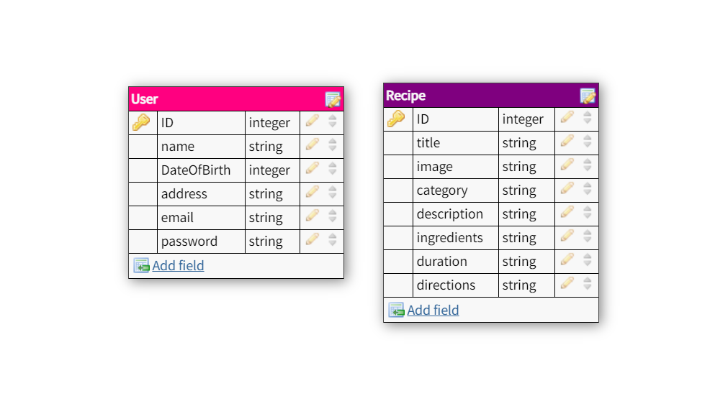

* **Website**

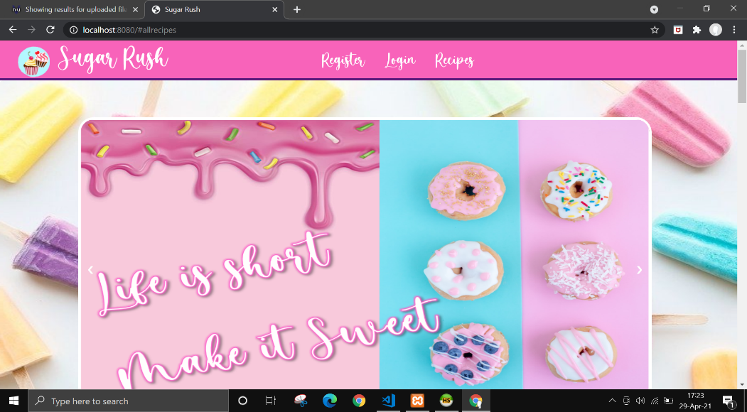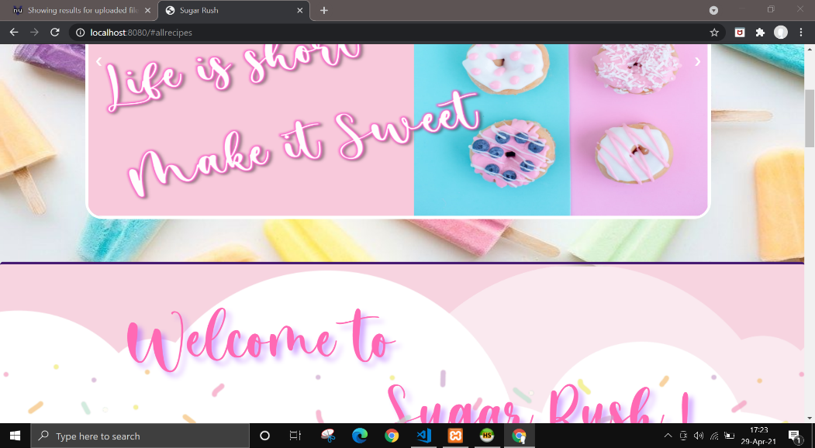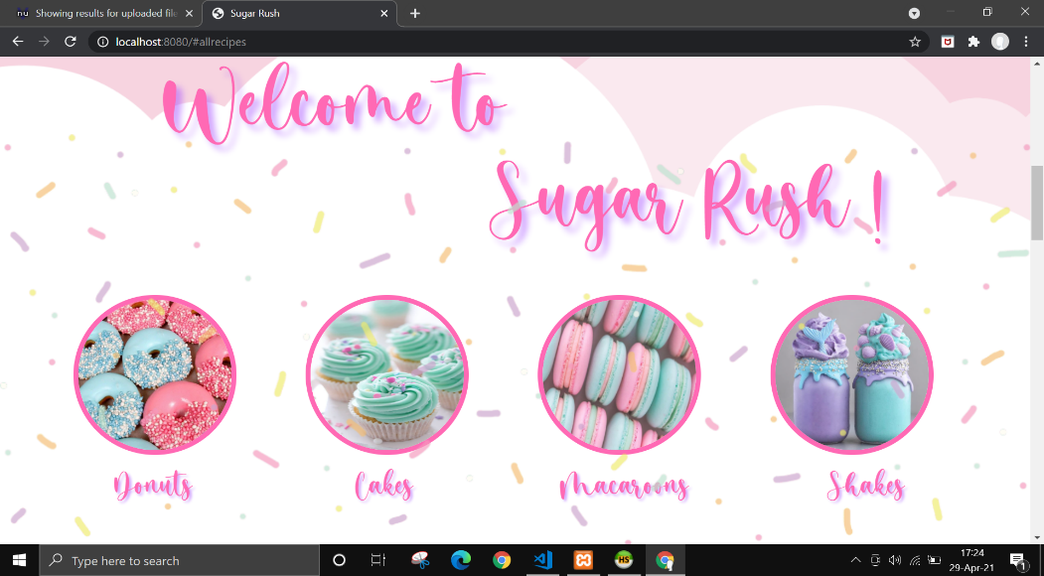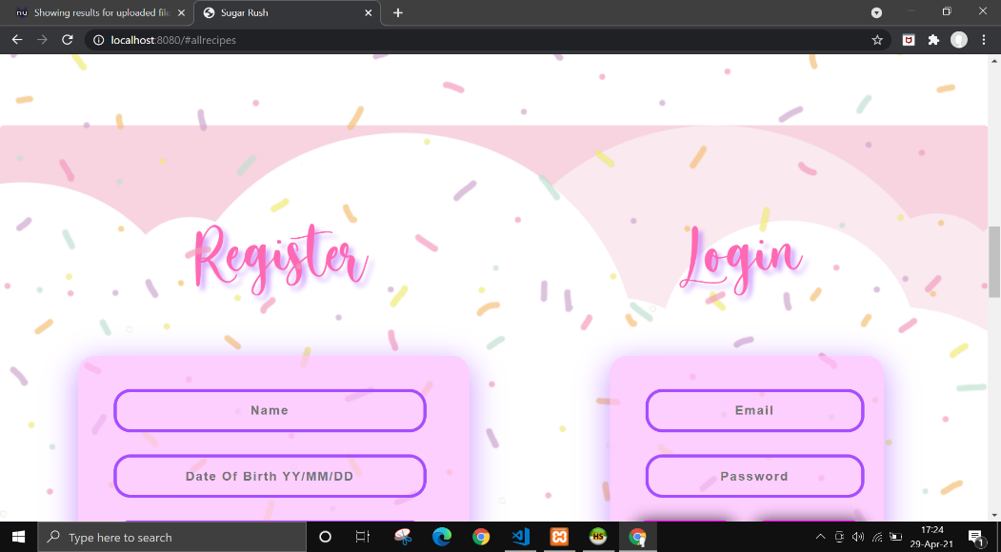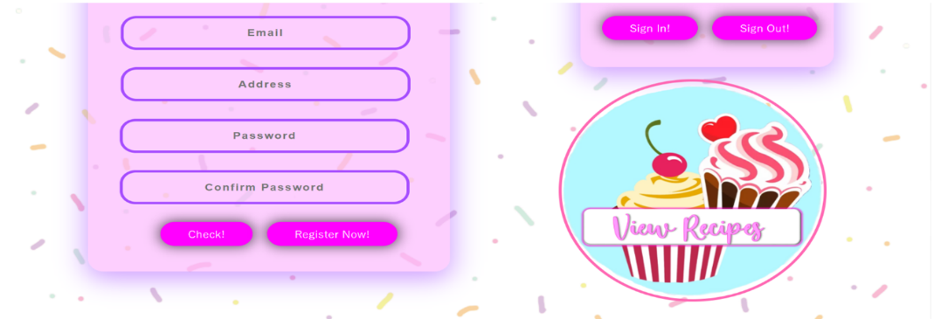

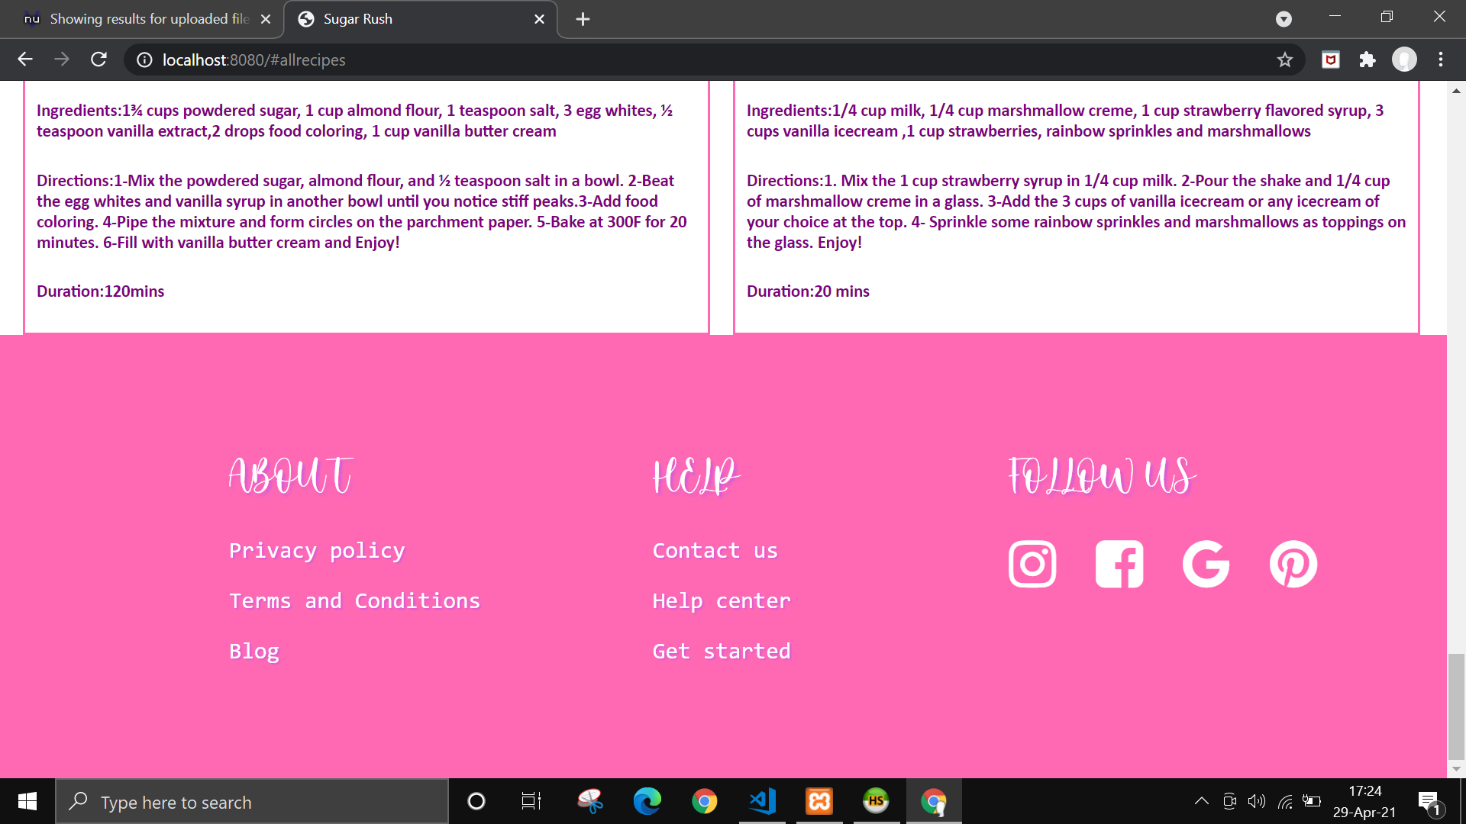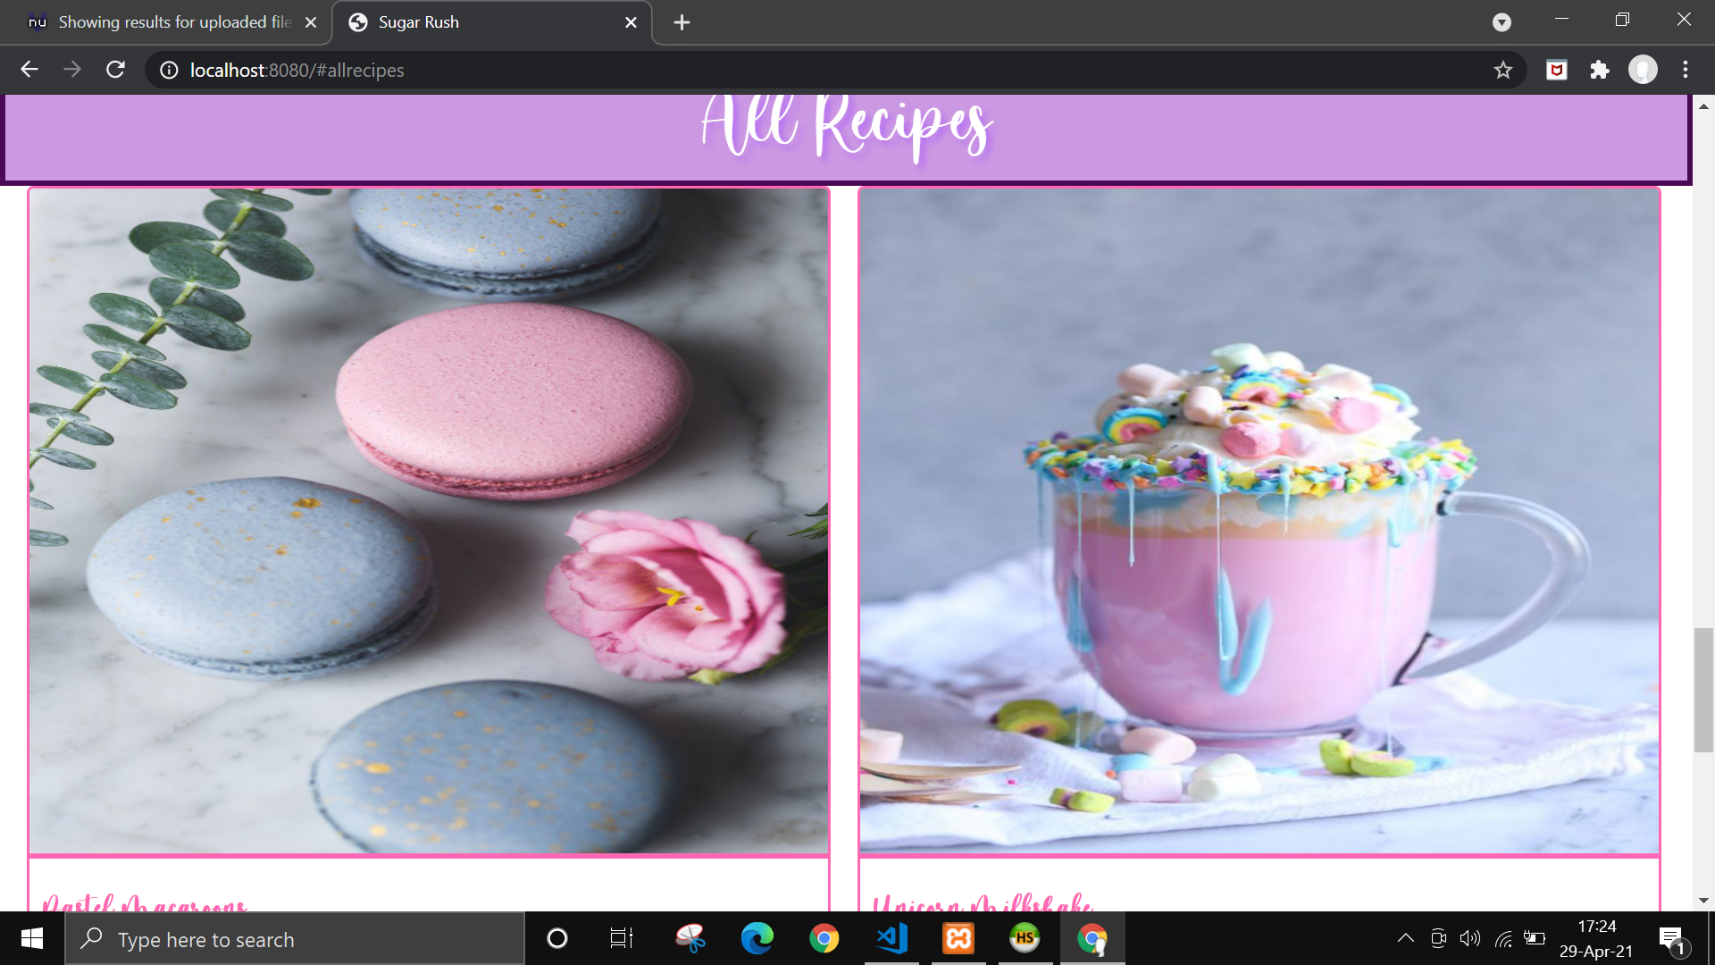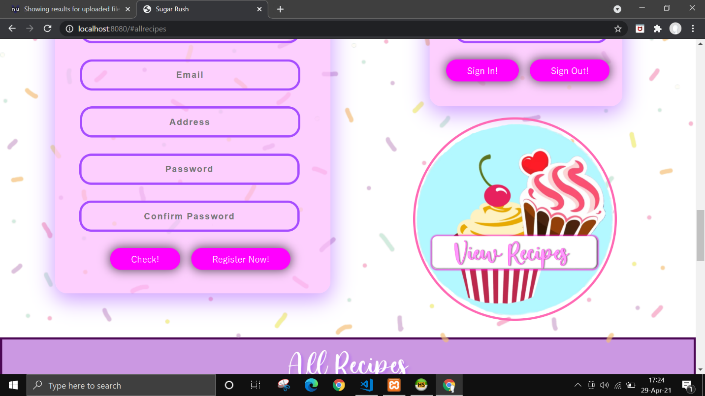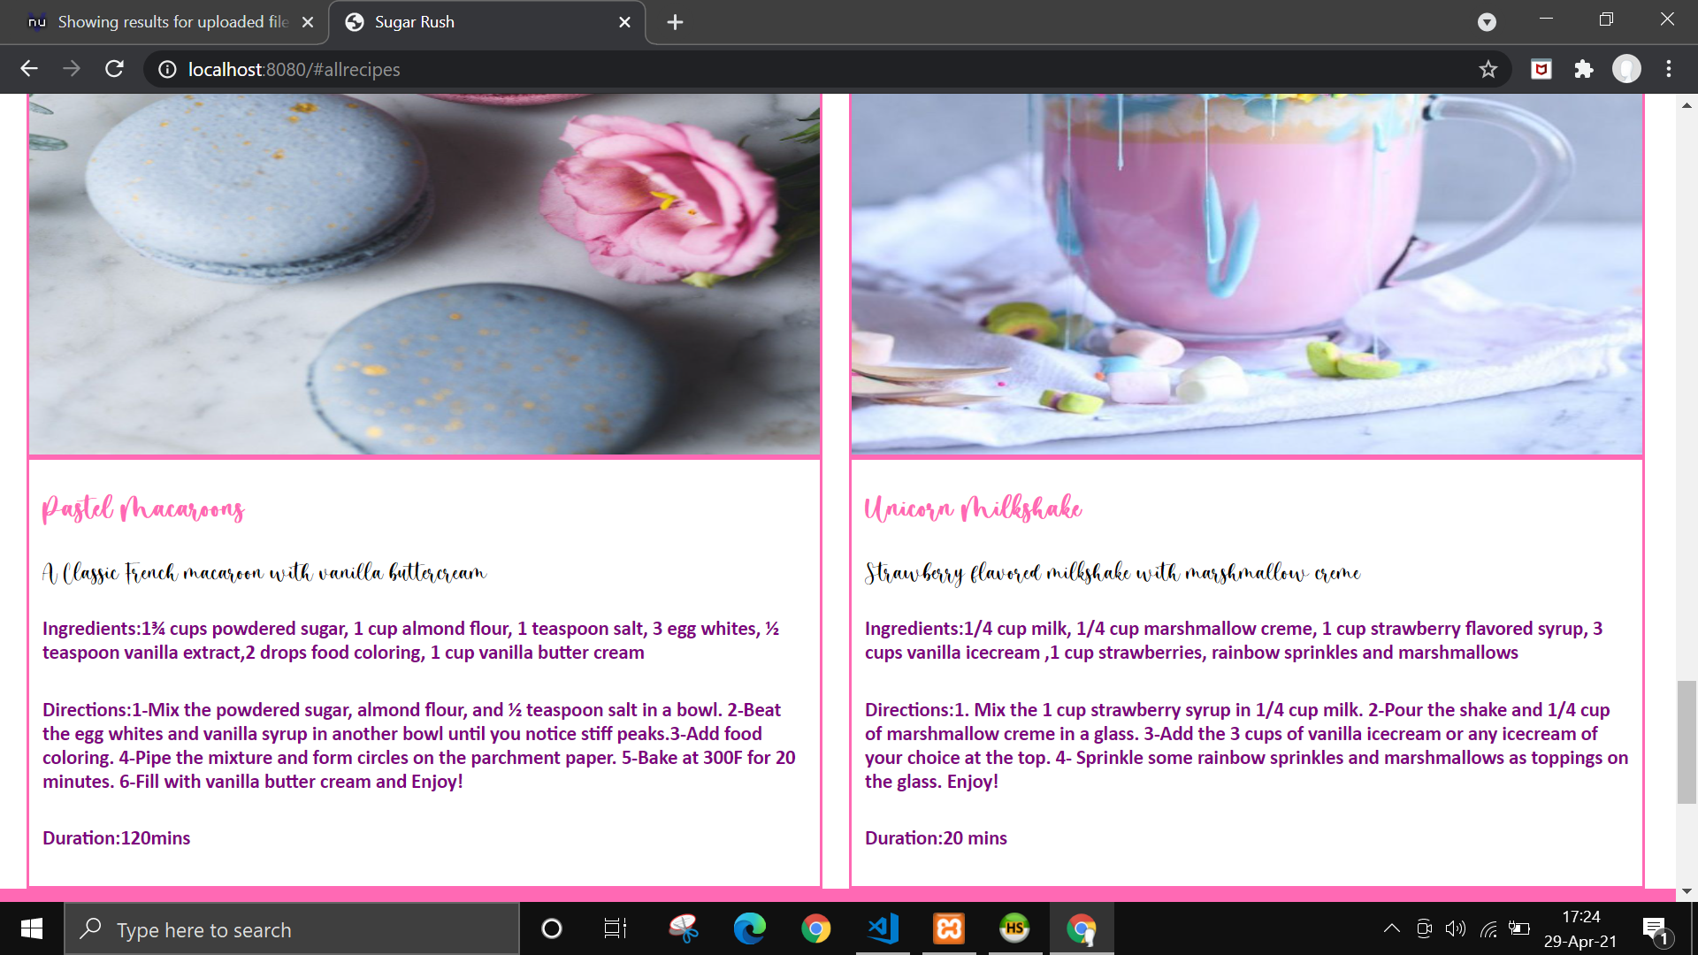**(Continuation of the single page website)**

# **Testing**

**Testing was done by carrying out HTML test, CSS test, Selenium test, and Chai and Mocha test.**

* **HTML testing**

**For testing the html page, Nu HTML checker was used. This detected 6 errors which were resolved.**

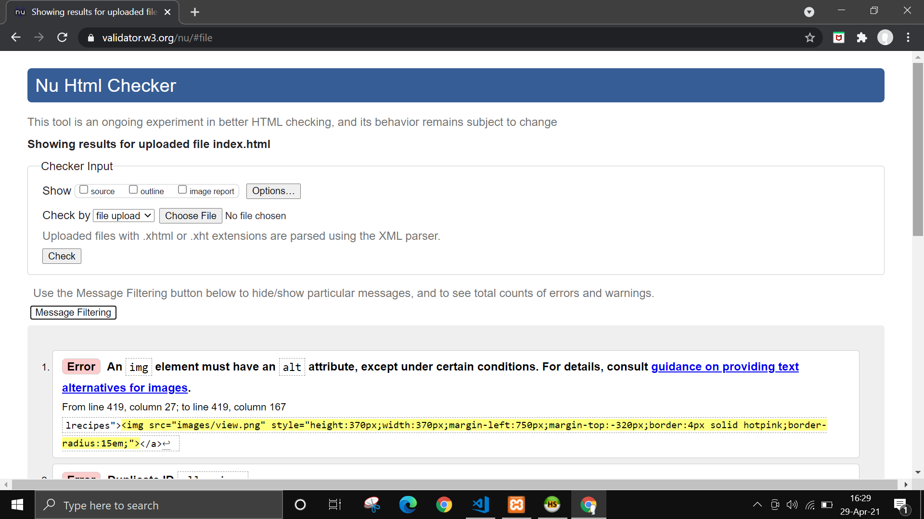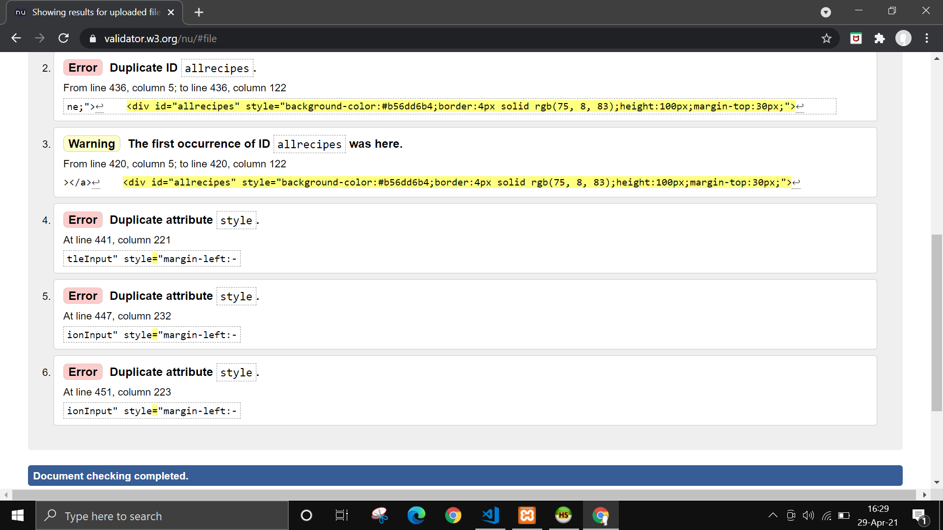

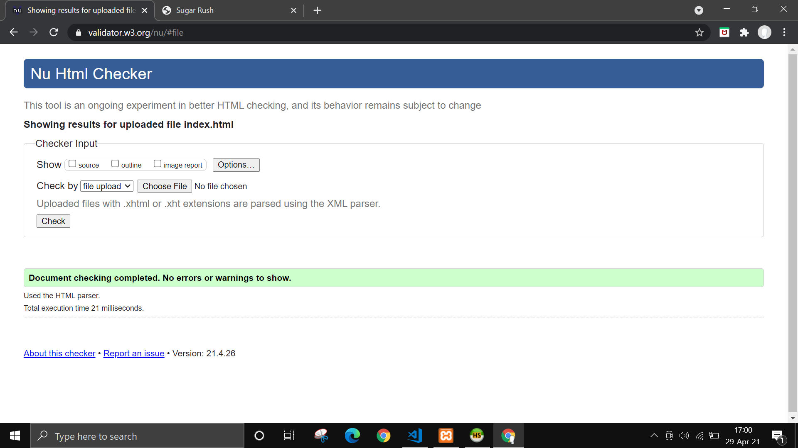**After resolving the issues, no errors were displayed.**

# **CSS Testing**

**For CSS testing W3C validation was used and no errors were detected in the styles.css.**

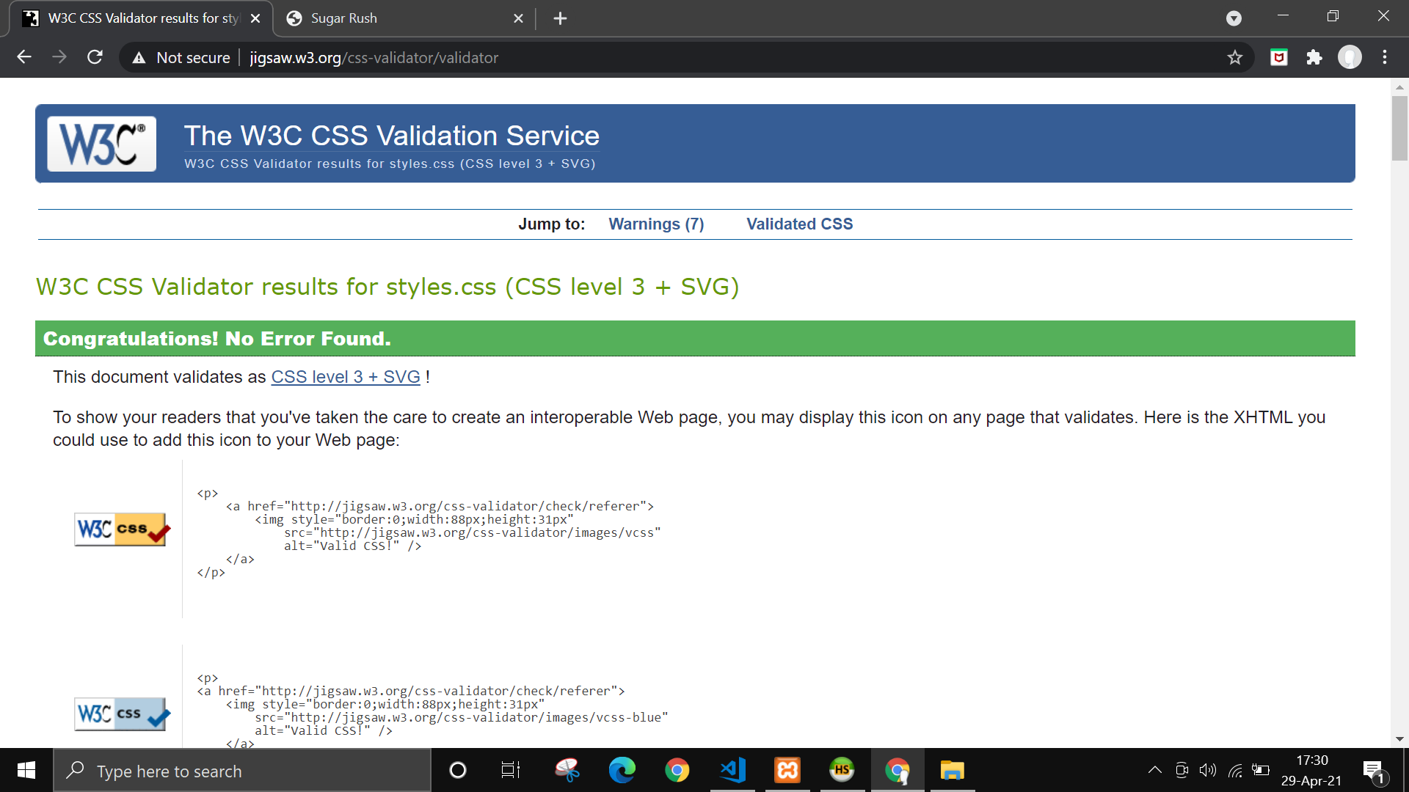

* **Selenium Testing**

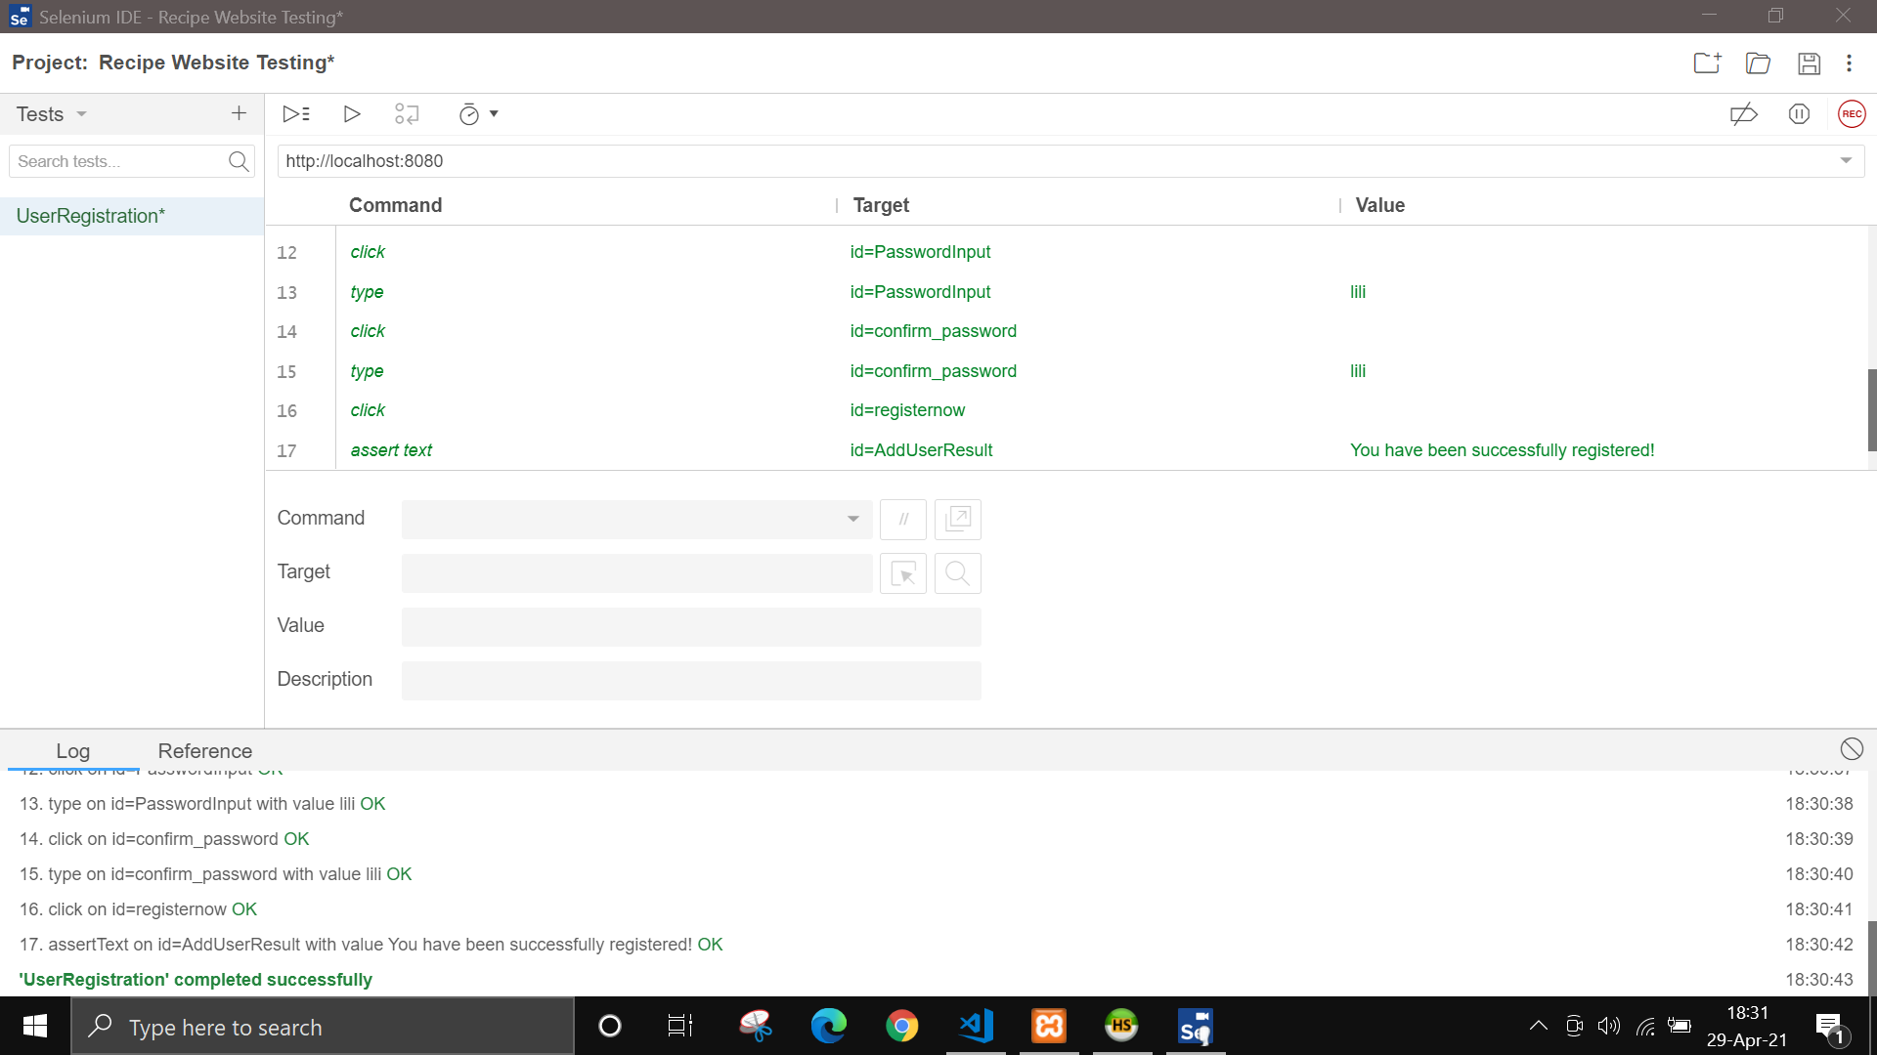**To check the functions of the website selenium IDE was used. Five selenium tests have been carried out successfully which are UserRegistration, CheckRegistration, UserSignIn, UserSignOut, and AddRecipe.**

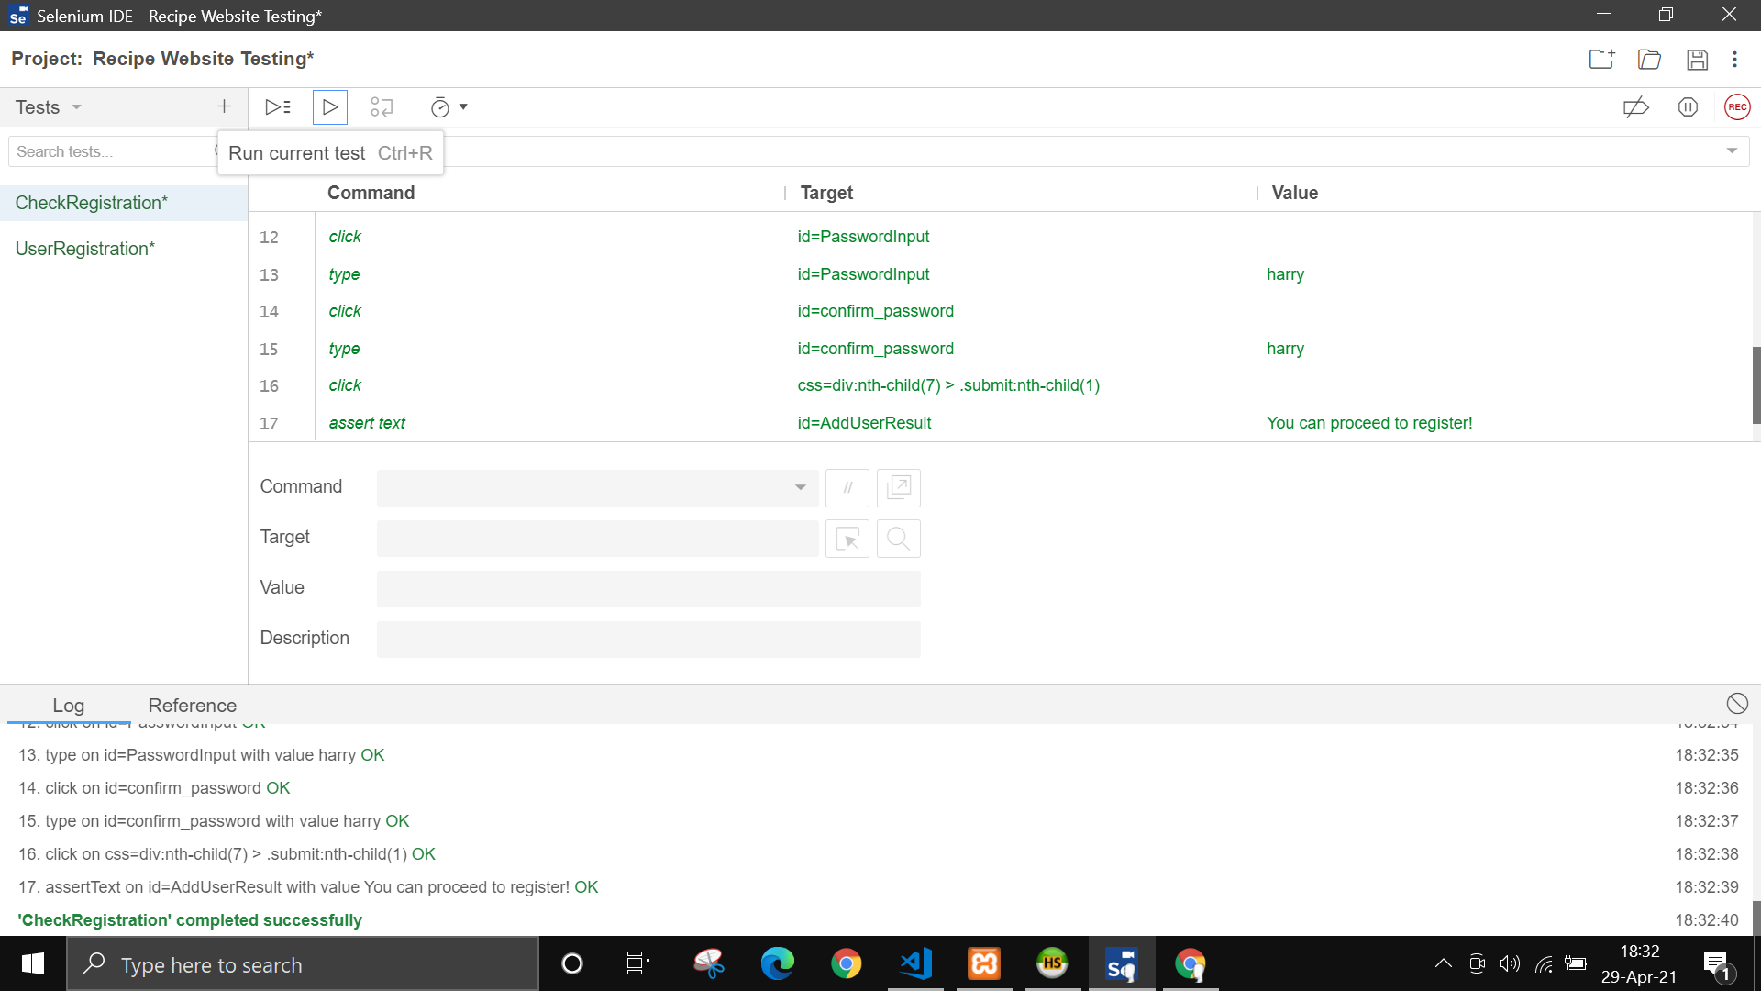

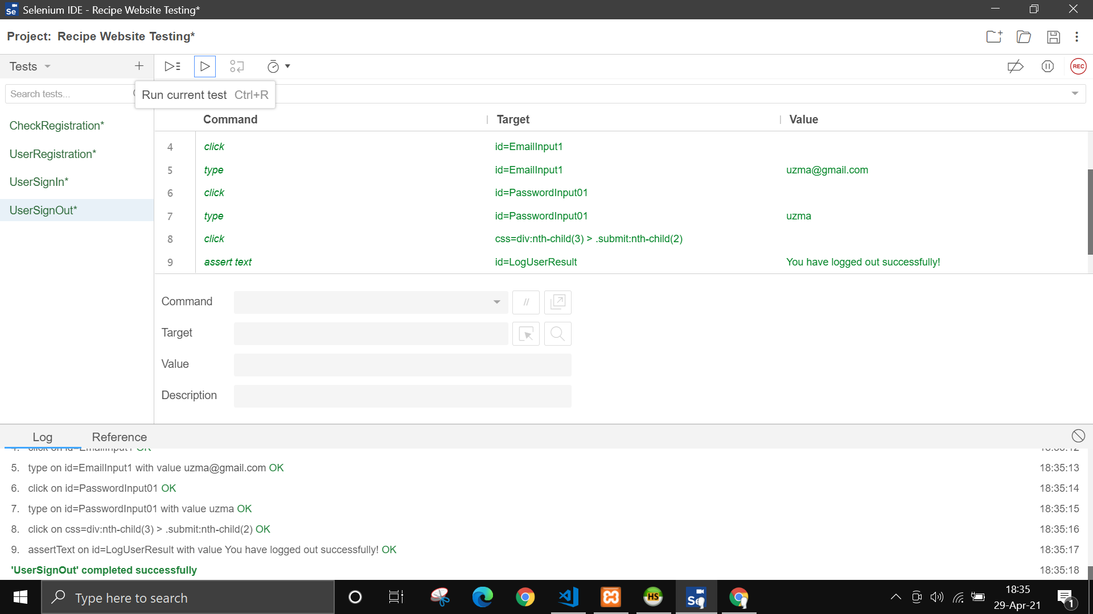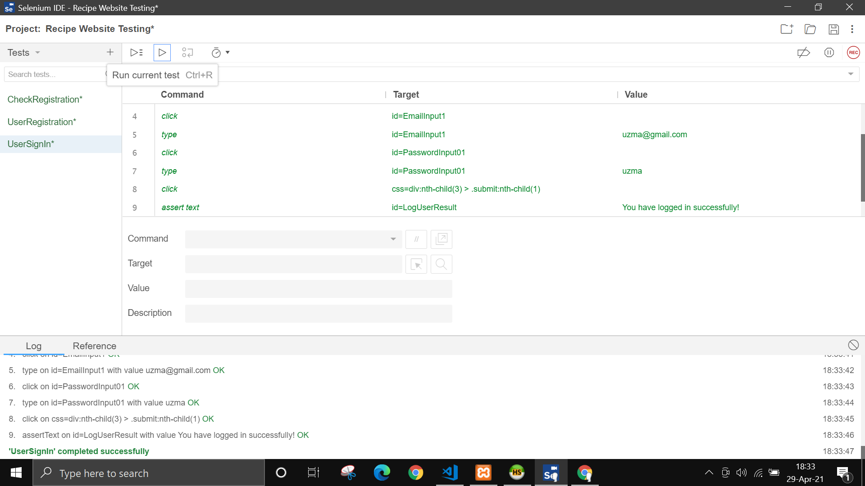

* **Testing with Chai and Mocha**

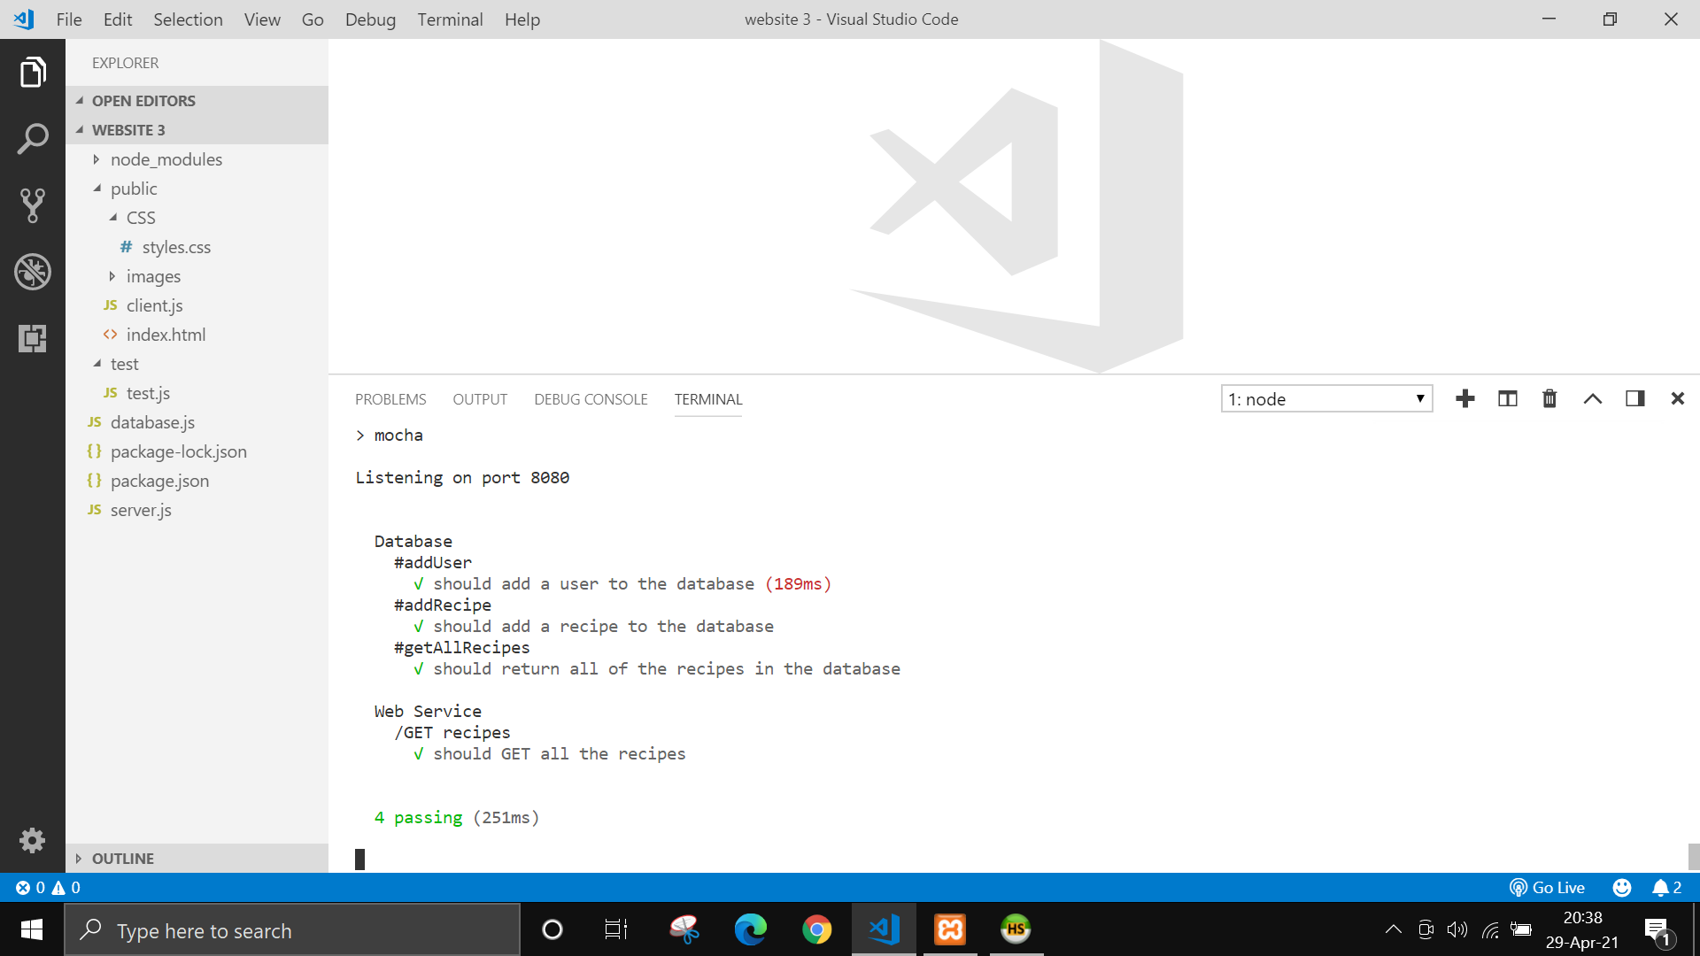**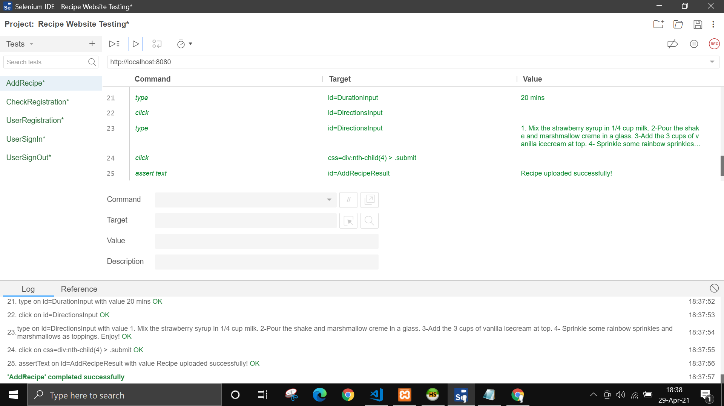The Database and the Web Service was tested by carrying out 4 tests.**

# **Conclusion**

**This coursework helped me gain lots of knowledge about how to work with SQL database and how to manage sending data with a single web page. I also learnt about different kinds of testing using selenium and Chai, Mocha which was a new concept for me. Attending the lectures and watching the video also helped me in understanding the concept better and doing the coursework. Overall it was a good experience.**